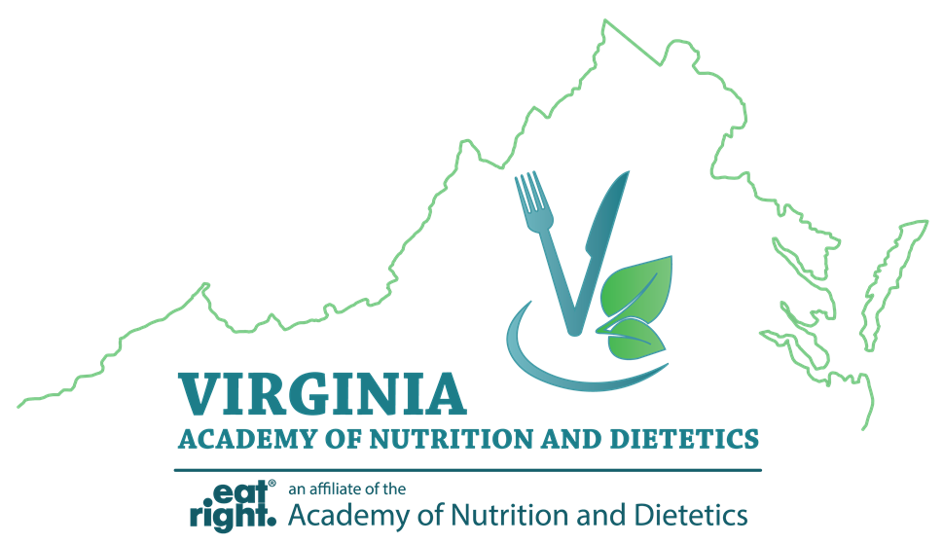

Virginia Academy of Nutrition and Dietetics
Abstract Form

Abstract submissions must follow the 2018 Poster Session Guidelines. All submissions must be sent as an email attachment to crwynn@vsu.edu no later than February 9, 2018. Please type VAND Poster Abstract into the subject line of your email. Authors will be notified of their selection to participate in the poster session by February 26, 2018.

Name of Presenting Author:
Address:
Telephone:
E-mail:

Title:

Author(s):

Learning Outcome:

Abstract:

