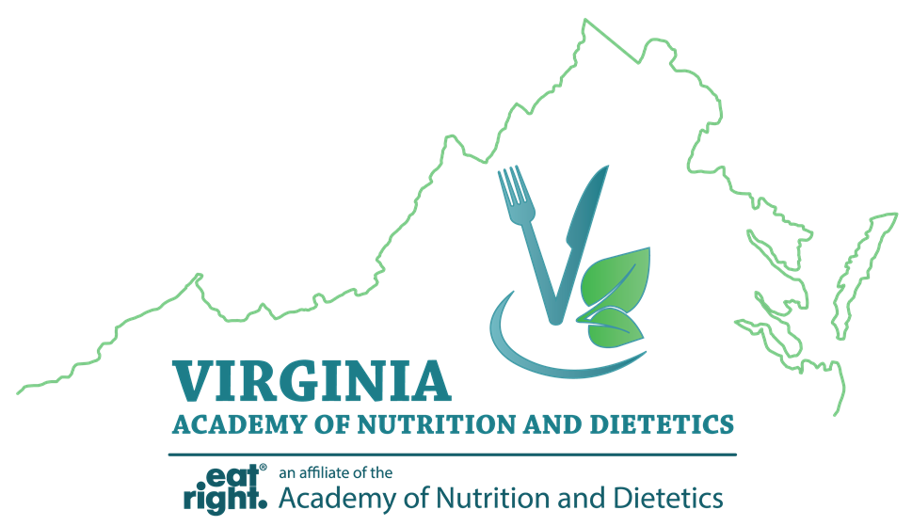

Virginia Academy of Nutrition and Dietetics
Abstract Form

Abstract submissions must follow the 2019 Poster Session Guidelines. All submissions must be sent as an email attachment to Rebecca Heming at RLH9CP@virginia.edu no later than February 15, 2019. Please type “VAND Poster Abstract” into the subject line of your email. Authors will be notified of their selection to participate in the poster session by March 4, 2019.

Name of Presenting Author:
Address:
Telephone:
E-mail:

Title:

Author(s):

Learning Outcome:

Abstract:

