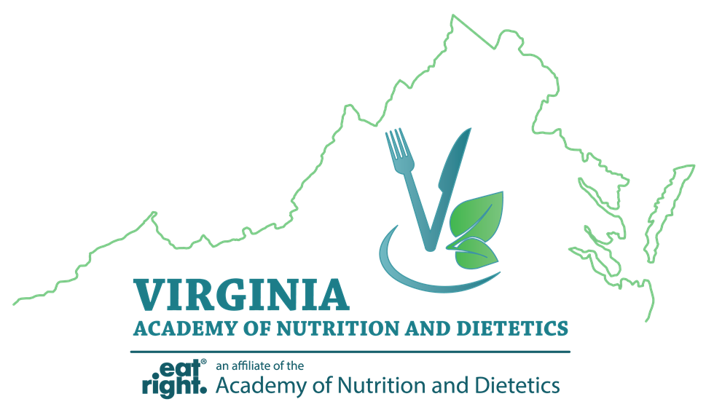

Virginia Academy of Nutrition and Dietetics
Abstract Form

Abstract submissions must follow the 2020 Poster Session Guidelines. All submissions must be sent as an email attachment to Keyla Sifre at Keyla.sifre@gmail.com no later than January 31st, 2020. Please type “VAND Poster Abstract” into the subject line of your email. Authors will be notified of their selection to participate in the poster session mid-February.

Name of Presenting Author:
Address:
Telephone:
E-mail:

Title:

Author(s):

Learning Outcome:

Abstract:

