VANDPAC Donation Request Form

Requests must be submitted two weeks prior to event for consideration.
Email request form to eatright.virginia@gmail.com

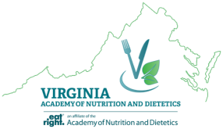

Requestor Information
Name: _______________________________________________________________________
Address: _____________________________________________________________________
Phone Number: ________________________________________________________________
VAND District: ________________________________________________________________

Legislator Information
Affiliation (e.g. R, D, I): _________________________________________________________
Committee(s) of Importance: ____________________________________________________
Leadership Position(s): _________________________________________________________
Previous VANDPAC Donations: _________________________________________________
Virginia District: ______________________________________________________________
Current Term (i.e. when is he/she up for reelection): ________________________________
History of support for nutrition issues: ____________________________________________

Event Information
Event Name: __________________________________________________________________
Event Location: _______________________________________________________________
Event Date/Time: ______________________________________________________________
Requested Funds: ______________________________________________________________
Return on investment (e.g. # tickets, etc.): __________________________________________
______________________________________________________________________________
Approximate size of event: ______________________________________________________
Rationale for attendance: _______________________________________________________
______________________________________________________________________________
For State Policy Representative Use
Amount Approved: ______________________________
Approving Official: ______________________________

