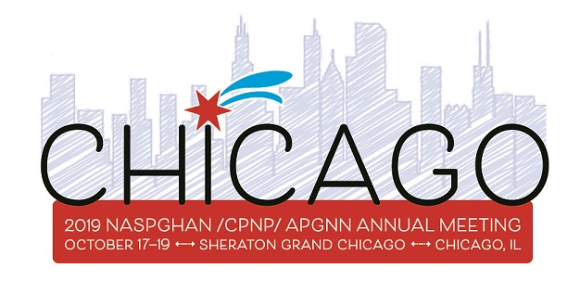
Save the Date! Plan on attending this year’s CPNP Nutrition Symposium October 18th and 19th in Chicago, IL! Your registration will allow you to attend any of the nonticketed sessions for CPNP, NASPGHAN, and APGNN meetings.
Thursday, October 17th
Come a day early to attend NASPGHAN’s post-graduate courses. State of the art presentations include challenging celiac cases, new therapies in chronic cholestatic diseases, and role of the diet in IBD.

Friday, October 18th
NASPGHAN’s Annual Meetings Nutrition Focused Topics include:
- Intestinal Failure and new fat emulsions
- Hot Topics and Blended Feeds
- Role of diet in IBD
New this year- CEU credit for RDs in these NASPGHAN sessions!!
APGNN morning session including Obesity education.

Saturday, October 19th, CPNP Nutrition Symposium Highlights
- Nutrition Support Teams: transitioning from inpatient to outpatient, formation and workings of a nutrition support team
- Transplant Nutrition: pre- and post- transplant nutrition therapy focusing on liver and heart transplant
- Cystic Fibrosis: understanding the impact of the GI team on the cystic fibrosis patient, updates on nutritional care of the cystic fibrosis patient
- NICU Malnutrition: highlights and limitations of the NICU malnutrition consensus guidelines and tools for identifying malnutrition in the NICU
- The breakout sessions will include nutrition follow up of the post-NICU patient, thickening in pediatrics and a resource sharing session on low FODMAP diet.
Link to full CPNP Symposium Schedule, Saturday, October 19th:
http://members.naspghan.org/Annualmeeting/Speaker_Tabs/2019_Annual_Meeting/2019_Annual_Meeting_Program_at_a_glance/CPNP_Nutritional_Symposium.aspx

Please see online program for more information. Questions? Email us at cpnp.naspghan@gmail.com

