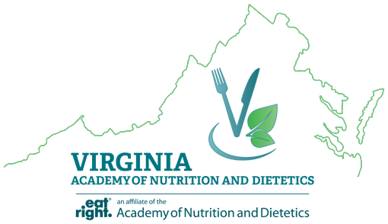

Supporter Membership Application
AND Active Membership is required to be approved as a Supporter Member.

Please complete the following:

Name: ___________________________________________________________________________
Academy Number: _________________________________________________________________
Primary Academy State Affiliation: ____________________________________________________
Mailing Address: ___________________________________________________________________
Phone Number: ____________________________________________________________________
Email Address: _____________________________________________________________________

VAND Supporter Membership Fees:
- Active Academy Member: $50.00/year
- Student or Retired Academy Member: $25.00/year

Instructions:
1. Save an electronic copy for your records of the following two completed documents:
- This e-application for Supporter Member
- Proof of Academy membership
- Print a “print screen” picture of your current profile at www.eatrightpro.org or make a paper or electronic copy of your current Academy membership card.

2. Email both documents to eatright.virginia@gmail.com or mail to:
Virginia Academy of Nutrition and Dietetics
P.O. Box 7061
Fairfax, VA 22039

3. The Executive Director of VAND will review your request and approve membership eligibility. This process may take up to 2 weeks. Please contact the VAND Executive Director with questions or comments at eatright.virginia@gmail.com or 703-815-8293.

4. Make payment: Payment is made after account approval.
a. You will receive an email with payment instructions once your supporter membership is approved.
b. Payment options are available using credit card or check.

